# **TIME**: 1 Hour

* A data sheet is supplied for student use

**NOTE:**

1. Calculations must show clear working with answers written in scientific notation stated to **three significant figures unless you are answering a question specifically asking you how many significant figures are technically required.**
2. Marks will be allocated for clear and logical setting out.
3. To help identify your answer, underline each answer.
4. State **assumptions** if working on open ended type questions.
5. Note that **NOT** all questions carry **equal** number of **marks**.
6. Answer **ALL** the questions.

Other constants required for this assessment:

Specific heat capacities of…

Aluminium = 900 J K-1 Kg-1

Copper = 390 J K-1 Kg-1

Plastic = 1·67 J K-1 Kg-1

Magnesium = 1050 J K-1 Kg-1

1. A simple heat pack can be made by stuffing a bag with wheat grain and heating the bag in a microwave.  
   How much energy would a microwave need to supply to a wheat bag with a mass of 850 grams to increase the temperature by 28 °C if the specific heat capacity of wheat is 1509 J kg-1 °C-1? [2]

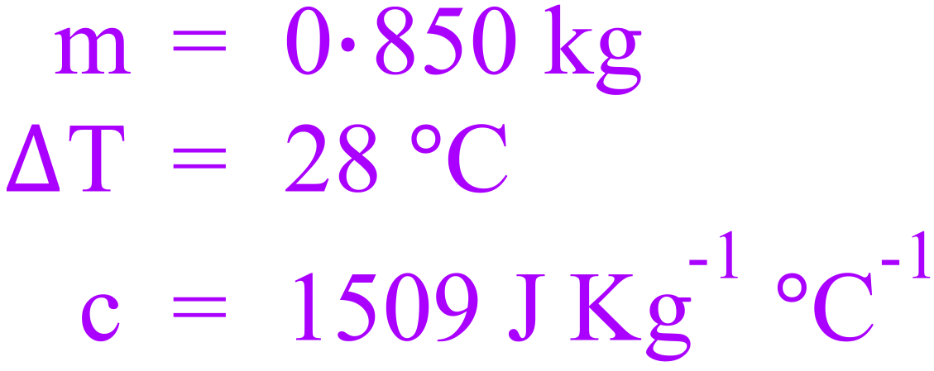 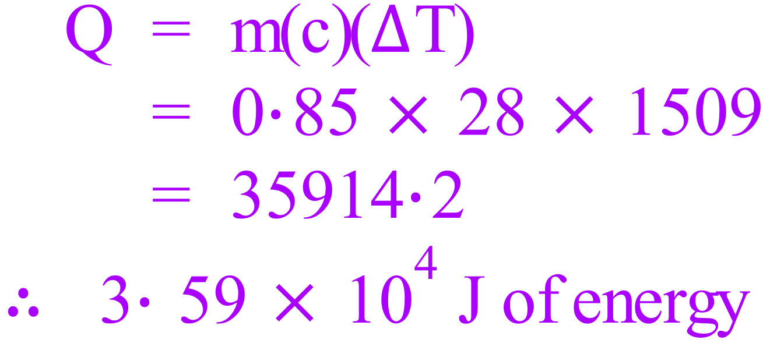

1. A 600 W camp-stove heats 0·75 kg of water in a 300 g aluminium kettle for 10 minutes from a starting temperature of 15 °C. Will the water come to the boil if the camp-stove is 75% efficient at transferring heat to the kettle? [3]

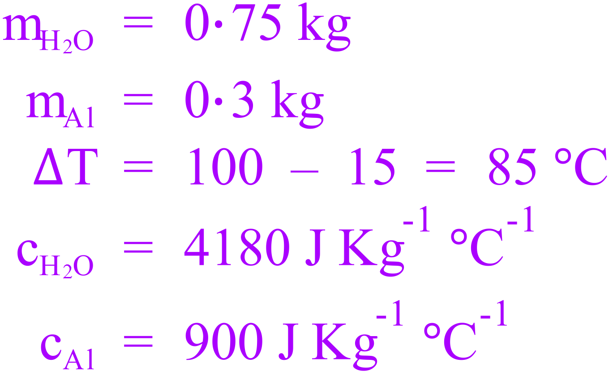 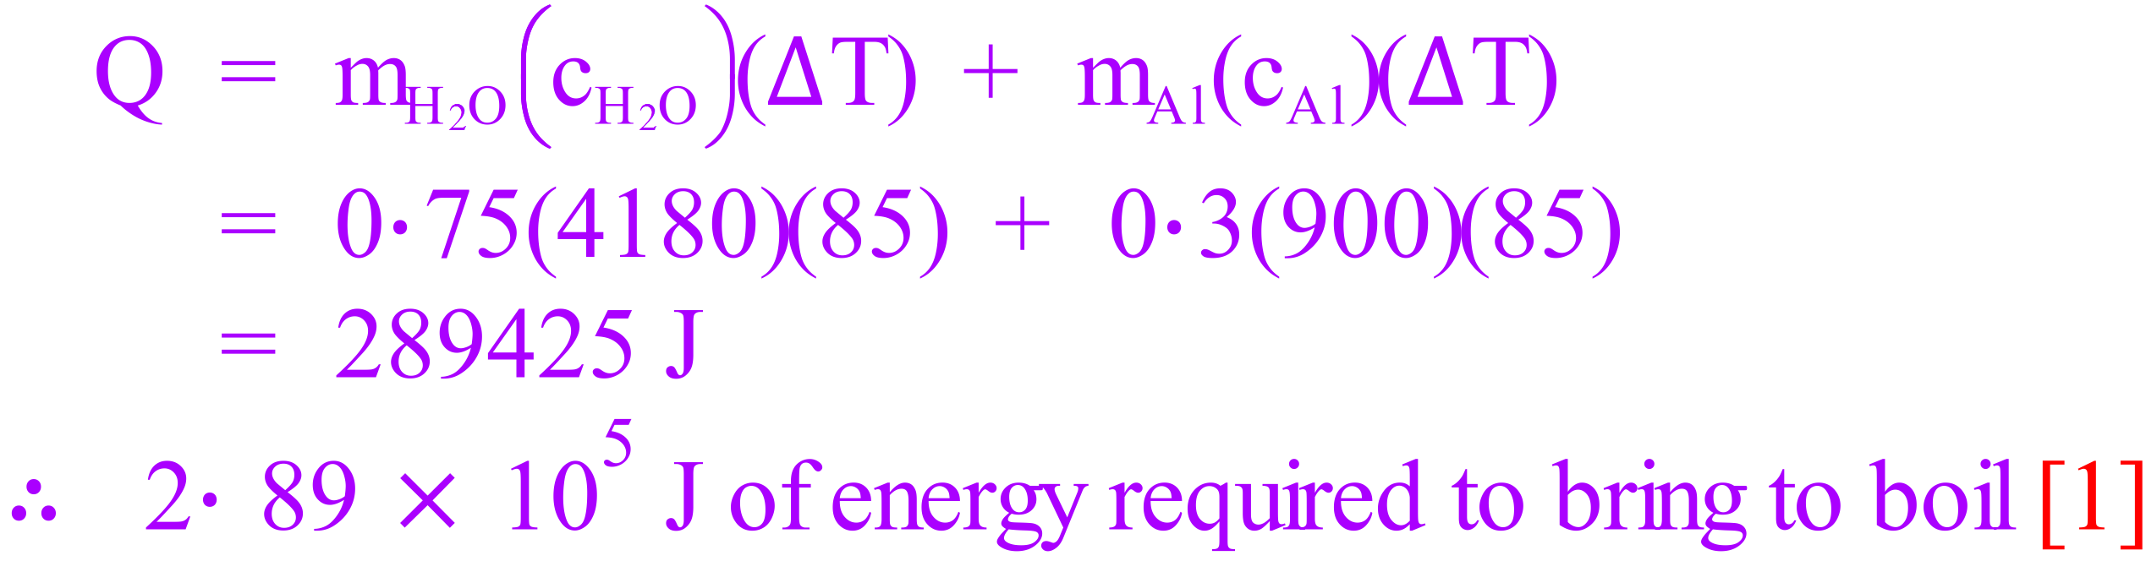

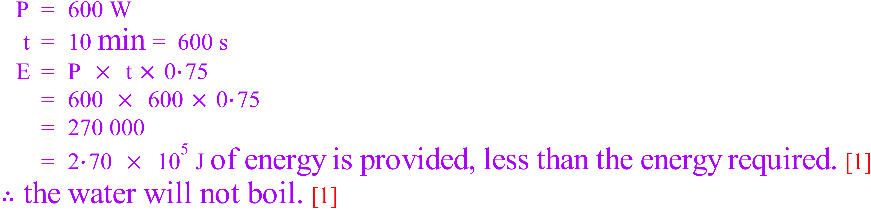

1. The safe bathing temperature for a new born baby is 36 °C. A mother of a new-born baby adds 1·5 litres of water with a temperature of 65 °C to a 2·3 kg plastic baby bath which is at room temperature (17 °C).
   1. What will the temperature of the water be when the water and bath reach thermal equilibrium?  
       [3]

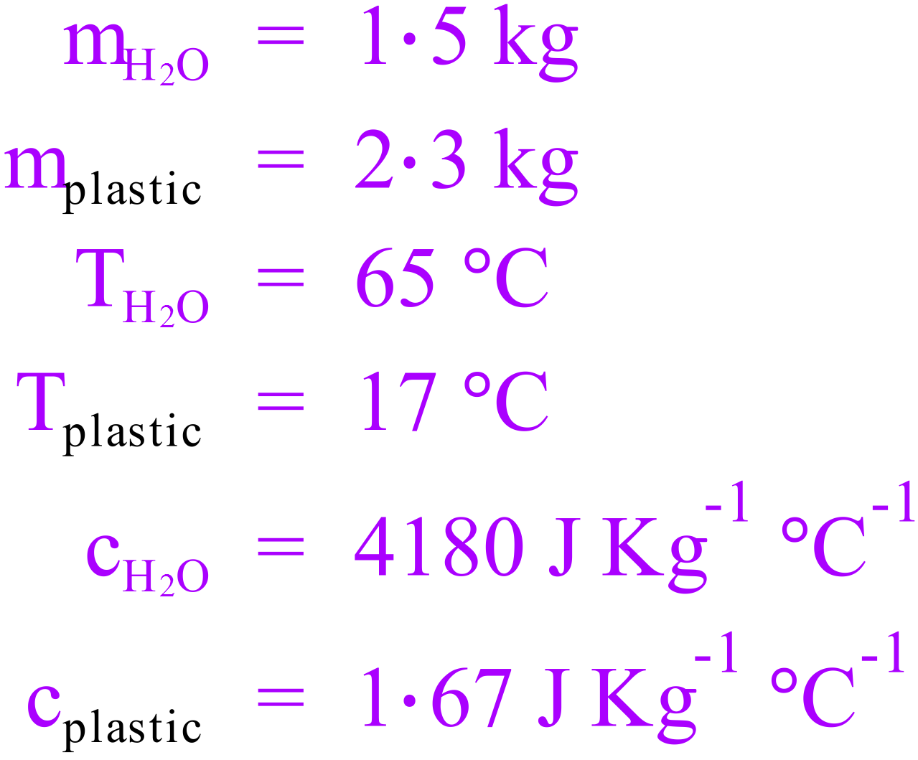 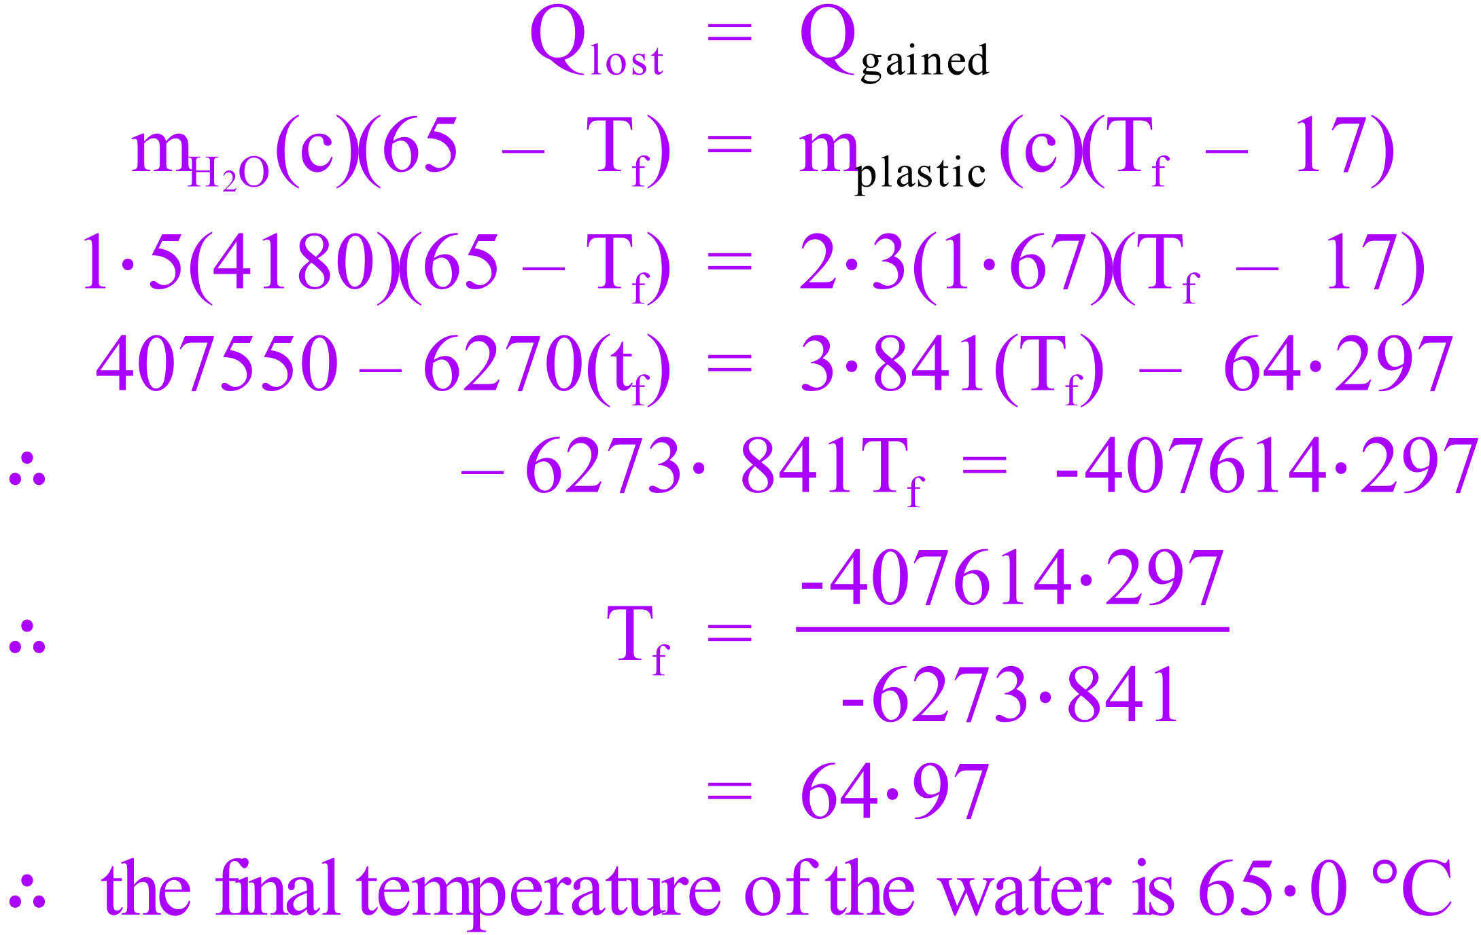

* 1. How much cold water [@ 22 °C] needs to be added to make the temperature of the water safe for the new-born baby? [3]

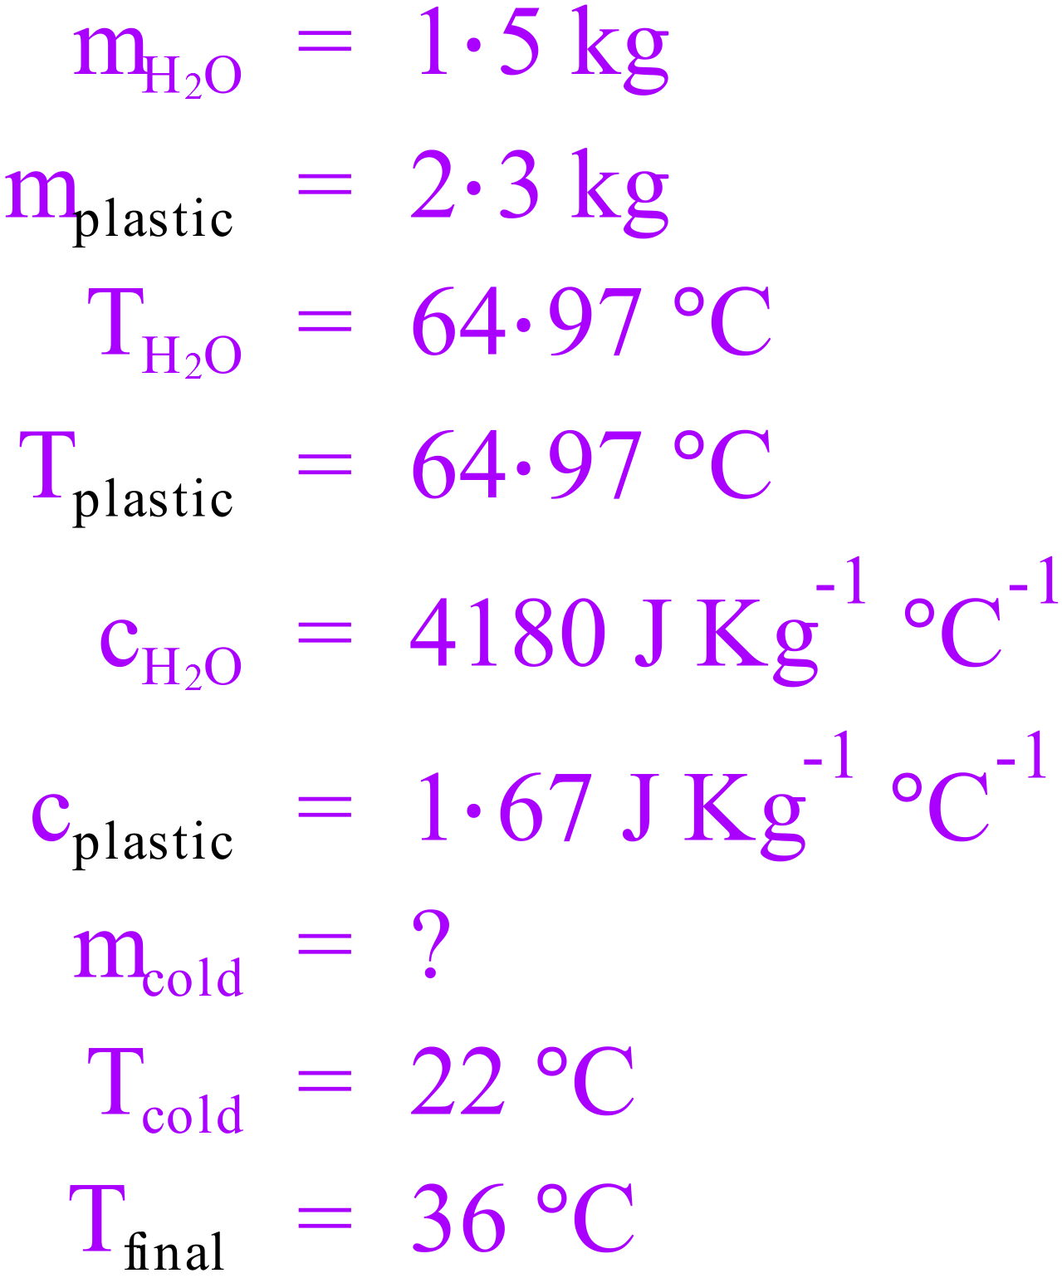 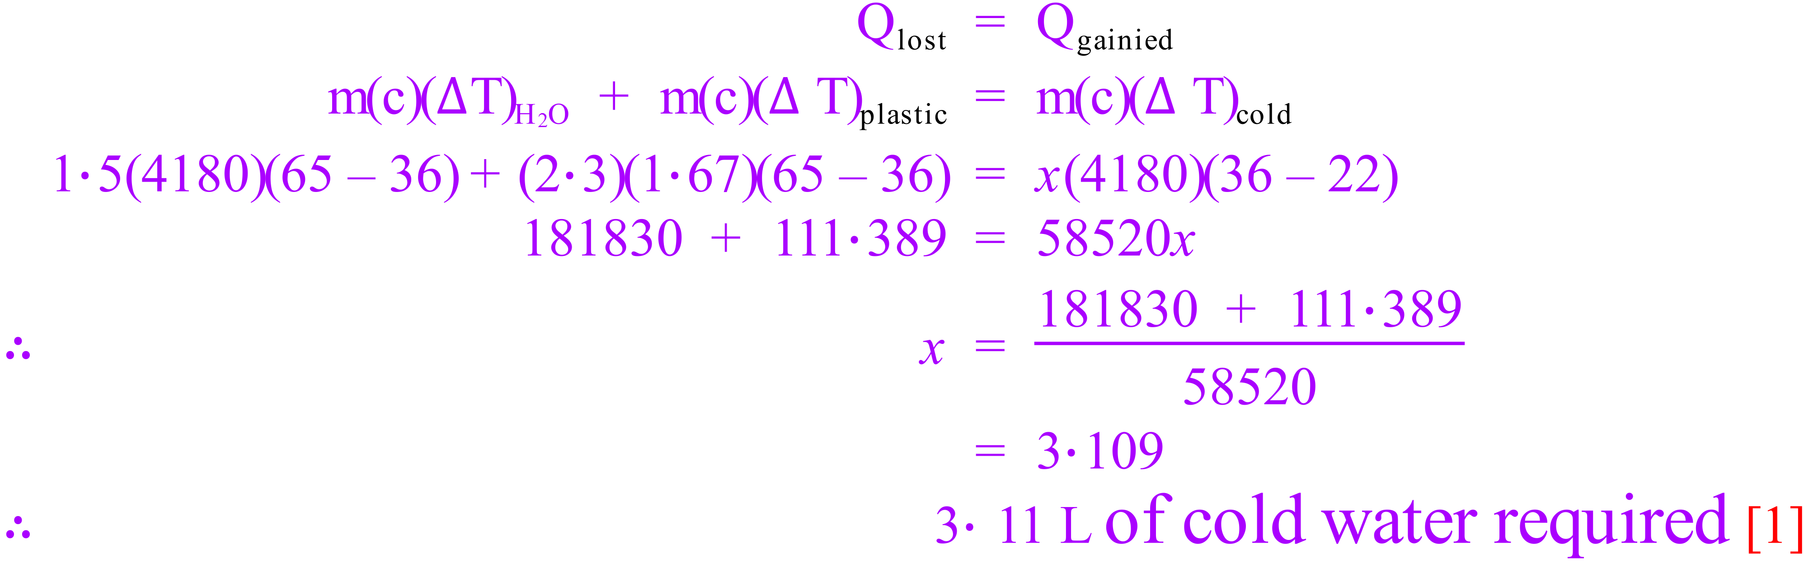

1. During its recent mission on Mars the NASA rover “Curiosity” discovered a new substance. Curiosity was able to isolate 1 gram of the substance and began heating it from the surface temperature of -55 °C. The graph below represents a summary of the data collected.

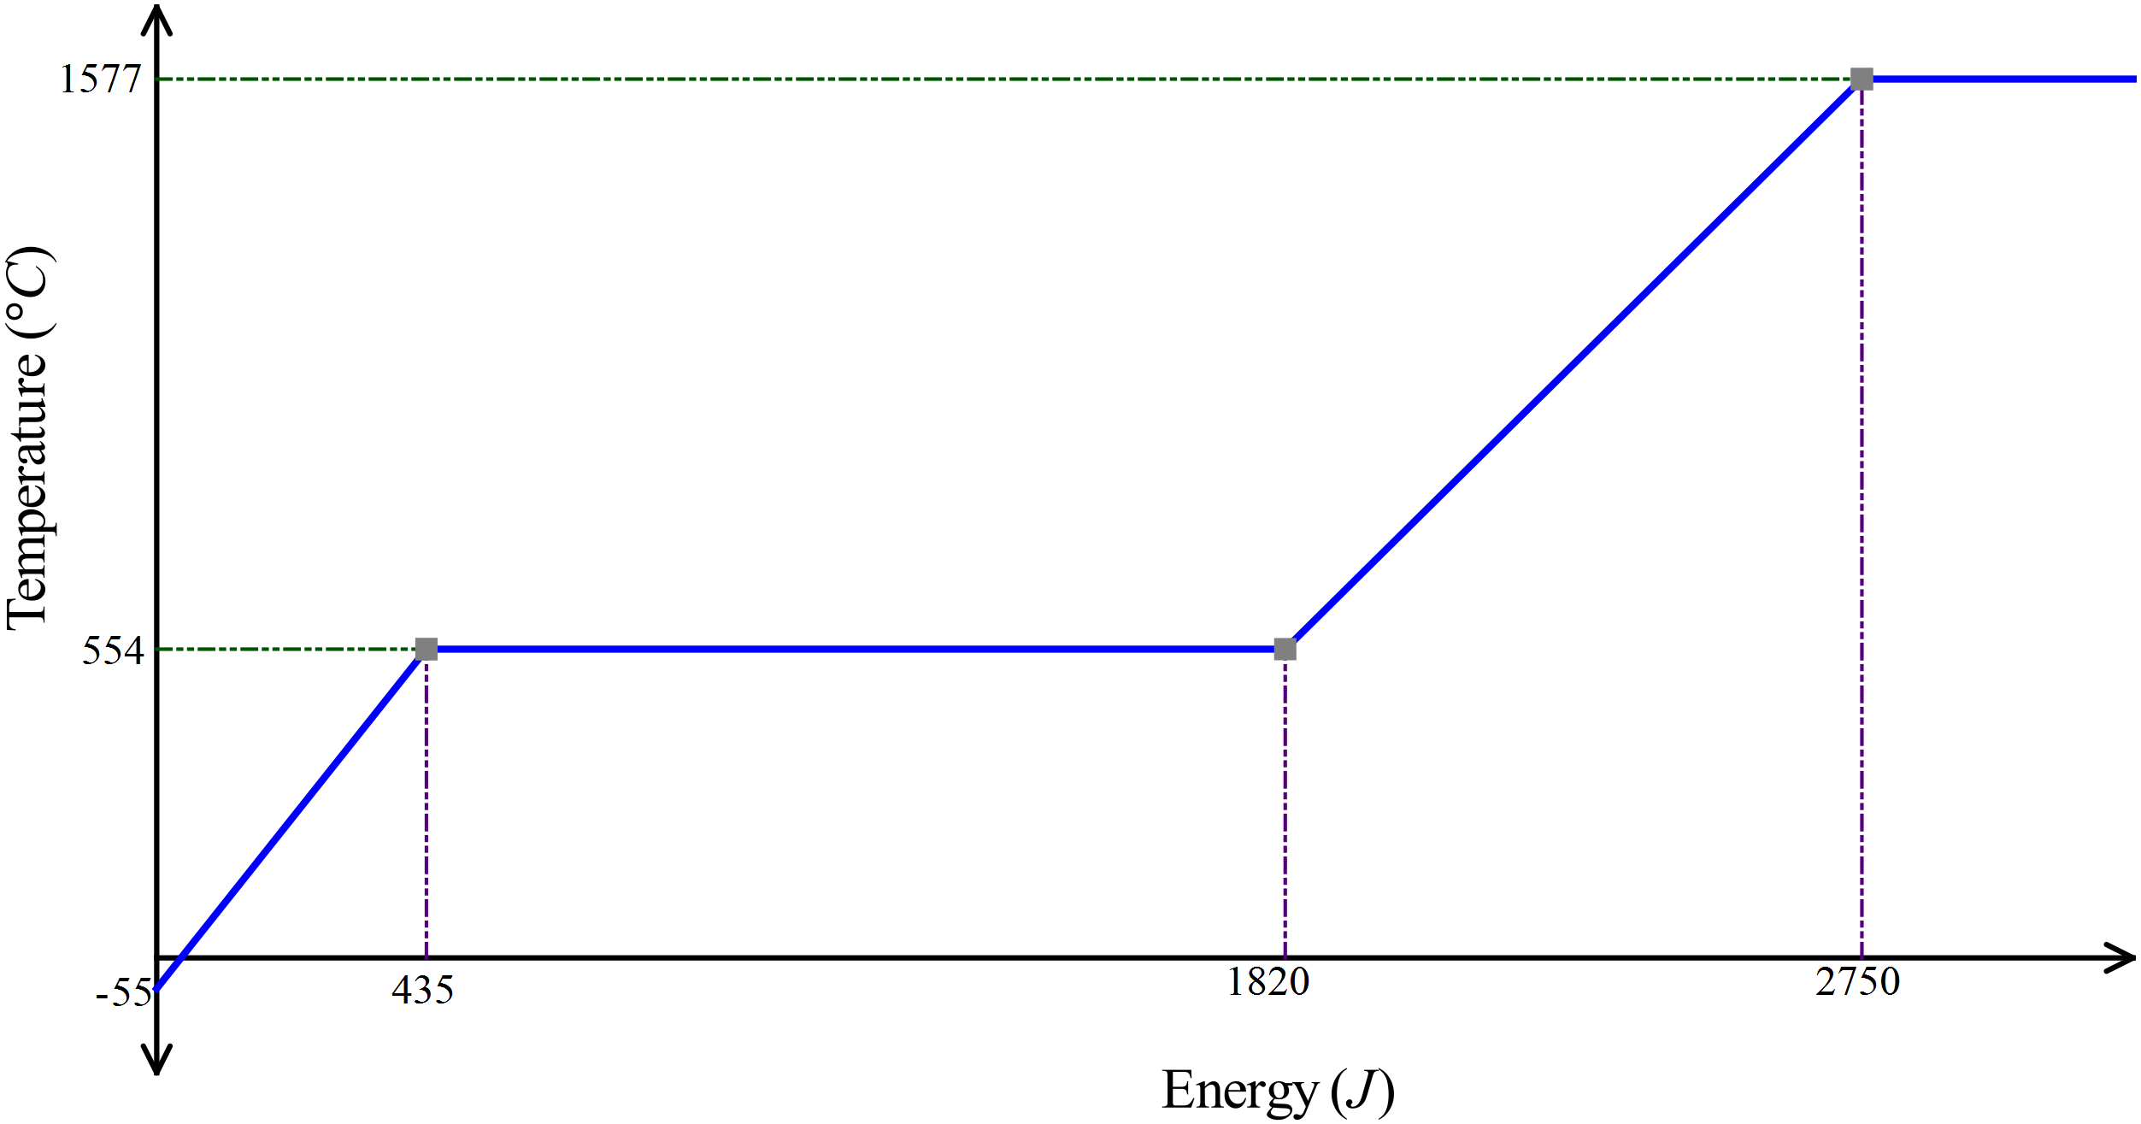

* 1. Explain why the temperature of the substance remains constant in the second part of the graph.  
      [4]

This part of the graph represents phase change (solid to liquid). [1]

The energy supplied goes into breaking up the crystalline structure (internal Potential energy). [1]

Temperature change is associated with change in internal kinetic energy. [1]

During phase change, internal potential energy is changed, not internal kinetic energy, therefore temperature remains constant. [1]

* 1. What is the melting point of this substance? [1]

554 °C [1]

* 1. What is the specific heat of the solid form of this substance? [3]

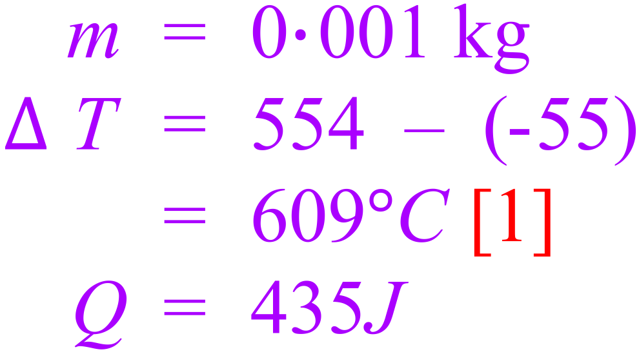 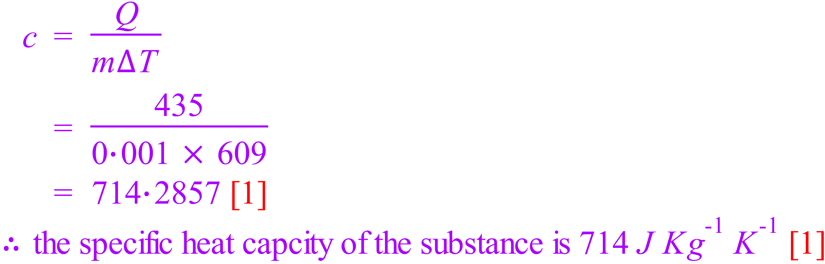

* 1. What is the latent heat of fusion for this substance? [3]

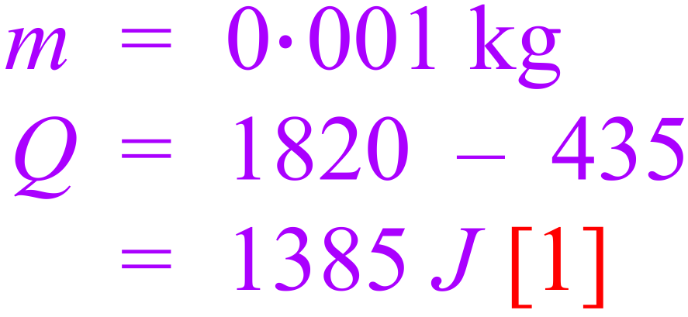 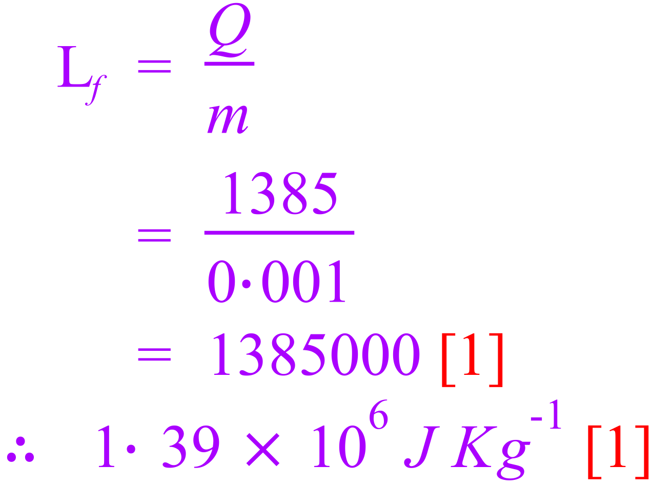

1. 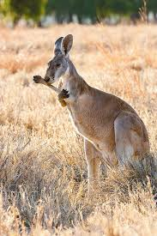Like many animals, Kangaroos do not have sweat glands. Kangaroos have been observed to repeatedly lick their forearms, coating an area of skin/fur close to blood vessels with saliva, which is essentially water.  
   Referring to heat energy concepts explain why this behavioural adaptation will lower the body temperature of the kangaroo. [3]

The process of increasing the temperature and evaporation of the water in the saliva requires energy. [1]

The energy required comes from the body/blood of the kangaroo. [1]

This exchange of energy results in a lower body/blood temperature. [1]

Can’t decide which answer, above or below.

The water in the saliva evaporates [1]

The process of evaporation involves particles with the highest kinetic energy leaving, lowering the average kinetic energy (and temperature) of the remaining molecules [1].

Heat energy is transferred from the kangaroo’s blood to the cooler saliva [1].

1. Consider a brick wall that has been exposed to the Sun for some time:
   1. How did the heat get from the Sun’s surface to the wall? [2]

As space is a vacuum [1], the only way the heat can get to the wall from the sun is radiation [1].

* 1. The air over the wall seems to shimmer and shake as air currents rise from it. Explain what creates these air currents. [2]

The air currents are caused by convection [1].

As air comes in contact with the wall, it is warmed (becomes less dense) and rises [1].

* 1. You can feel the wall’s warmth some distance away. How does this heat get to you through the air? [1]

Radiation

* 1. Which would you expect to be warmer after being exposed to the Sun for equal times – a white wall or a black wall? Explain. [3]

The black wall [1]

Black absorbs [1] converting the energy into heat, white reflects [1].

1. Distinguish between the following:
   1. Heating and Heat: [2]

Heating is the process of transferring internal energy from a hotter body to a colder body [1]

While this internal energy is being transferred it is referred to as heat [1].

* 1. Internal energy and temperature: [2]

Internal energy is the sum of the particles kinetic and potential energies [1].

Temperature refers to (or is a measure of) the average kinetic energy of the particles [1]

1. A sample of magnesium is heated at a constant rate. The graph below shows how its temperature varies with time.

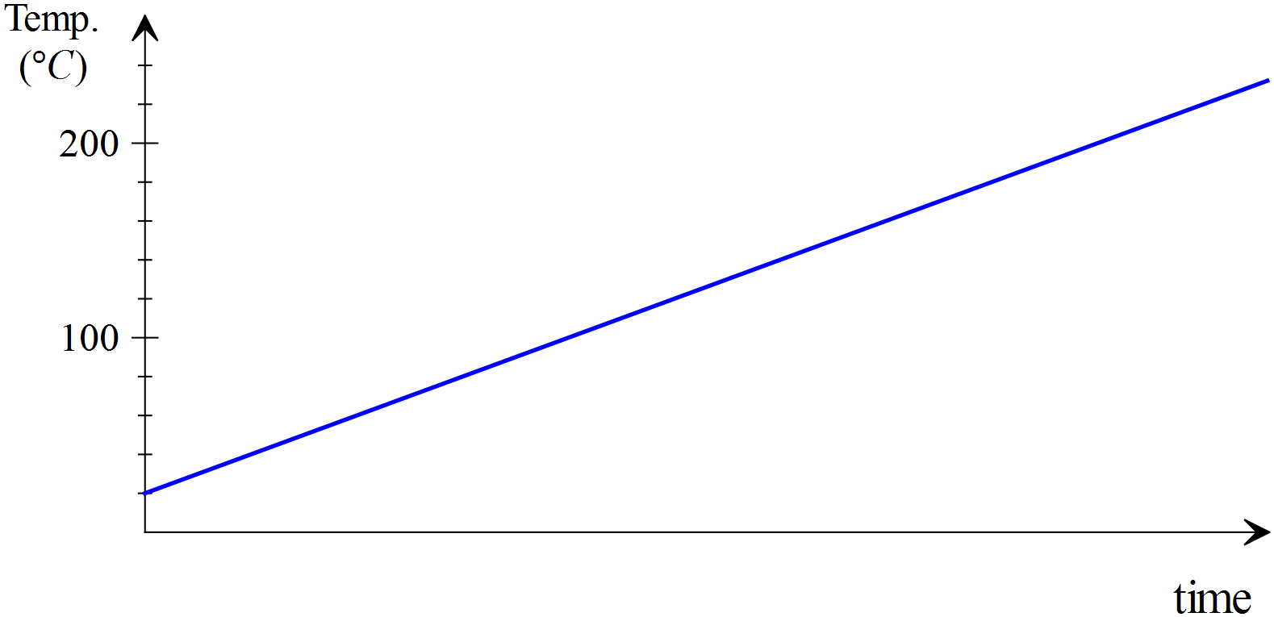

1. If an equal mass of copper at the same initial temperature is heated at the same rate, then the copper graph will be: **[select one of the following by ticking the corresponding box]** [1]
   * 1. Identical to the magnesium graph. □
     2. Steeper in slope. 🗹
     3. Less steep in slope □
2. Explain your answer to ‘a’ [2]

The specific heat of copper is less than magnesium [1],

The same amount of energy will cause a greater temperature change. [1]

1. What does the slope of the graphs tell us? [1]

The inverse of specific heat of the substance

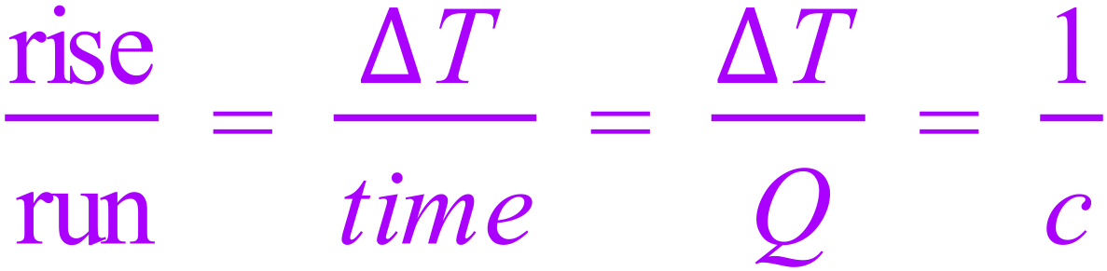

1. Using the models of matter explain the following:
   1. Why solids have a fixed shape but liquids and gases do not: [2]

The particles of a solid are held in a fixed lattice, so they are held relative to each other in a fixed position meaning that the whole object has a fixed shape [1].

The particles of liquids and gases are not held in a fixed position relative to each other, so the whole object does not have a fixed shape [1].

* 1. Why gases can be compressed but solids and liquids cannot: [2]

The molecules of a gas are widely spaced relative to their size, they can be readily pushed together [1].

The molecules in solids and liquids are packed closely together, leaving little or no space for compression [1].

1. Which absorbs more heat? 15 grams of water or 150 grams of copper when they both experience a 5 °C increase in temperature. [3]

The specific heat of water is more than ten times the specific heat of copper [1], given that the mass of water is one tenth of the copper [1], the water would absorb more energy for the same temperature change [1].

Or calculate the actual energy absorbed by each.

1. How much steam at 110 °C must be added to 40·0 g of ice at -6·00 °C in an insulated aluminium calorimeter of mass 53·0 g so that the ice melts and the final temperature of all the water is 5·5 °C.  
   [cAl = 900 J Kg-1 °C-1] [5]

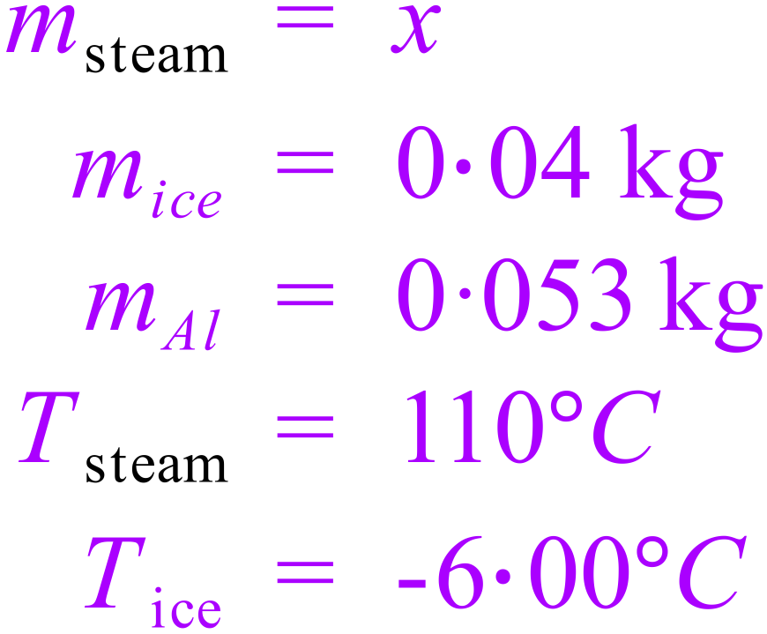 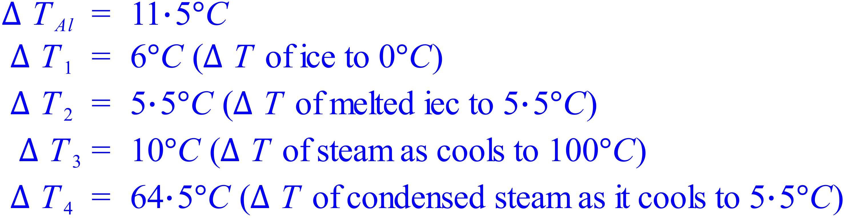

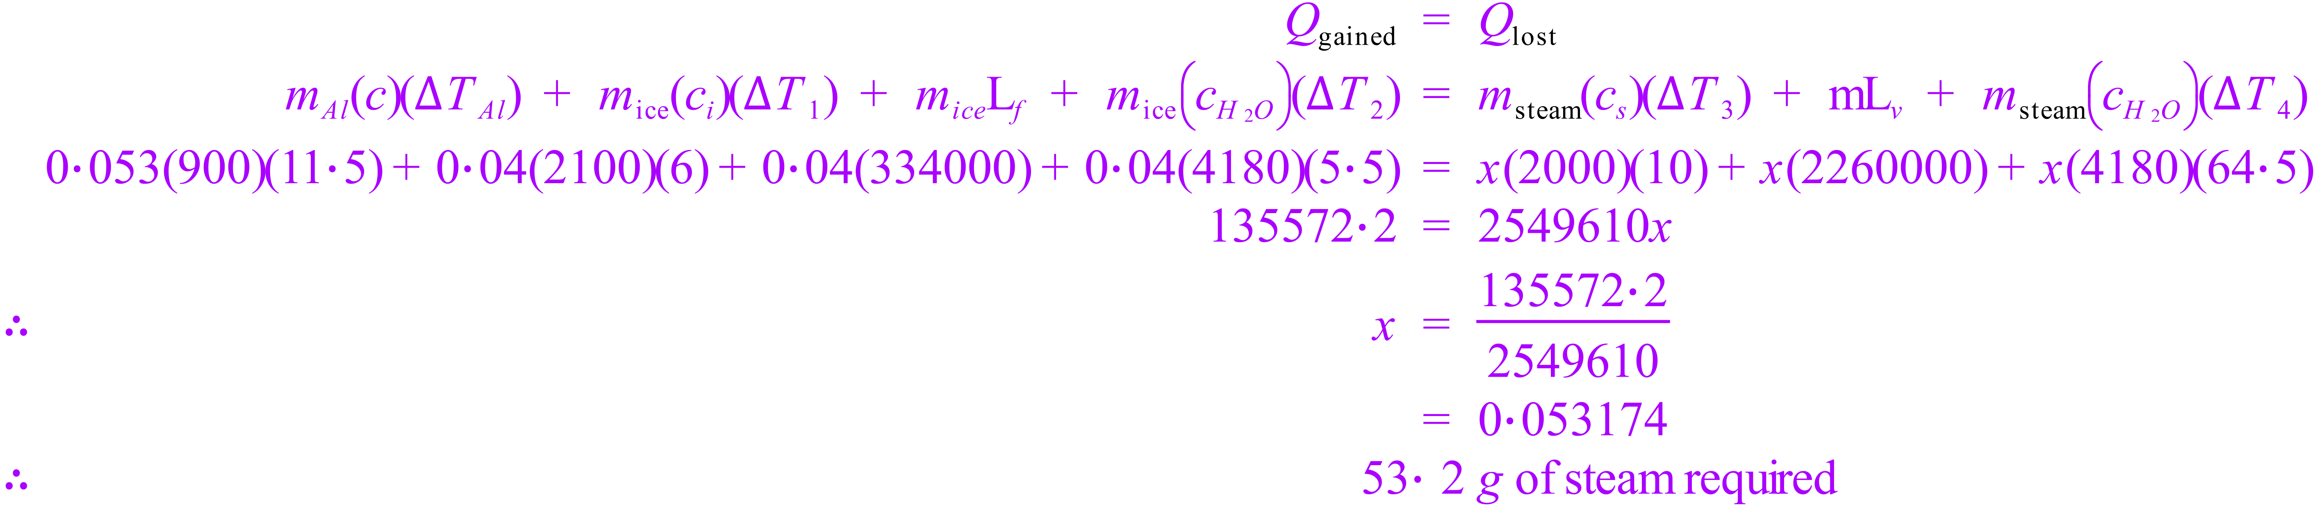

End of Test